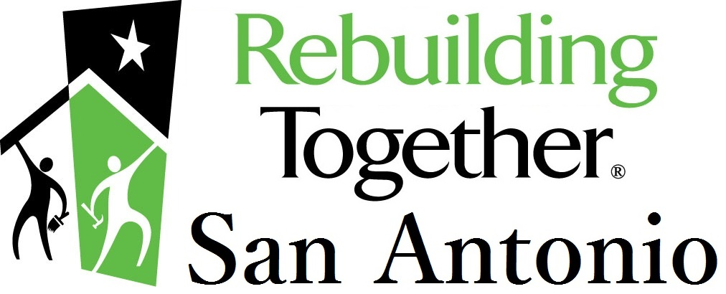

RebuildingTogether-SA.org 210.421.1111 P.O. Box 691881, San Antonio, TX 78269

Dear Homeowner,

Rebuilding Together™ San Antonio is a non-profit organization that repairs homes of San Antonio and Bexar County residents who are unable to do the work themselves. If your home is qualified, approved and selected for the Rebuilding Together™ San Antonio program, there would be no charges or cost involved for our services by volunteers, contractors or a combination thereof.

Sincerely,
Rebuilding Together™ San Antonio

To proceed you must meet the following requirements:

- Own your home (registered with the Bexar County Appraisal District in your name)
- Reside in San Antonio or Bexar County,
- Be elderly, handicapped, qualify as a low-income household, disabled or a veteran.

Homeowner’s Application (Please Print)

Name(s): __________________________________________ Primary Phone Number: _________________________

Address: __________________________________________ Homeowner’s Age(s): ________ Years at Address: ____

City: __________________________ Zip Code:________ Are you a U.S. Armed Forces vetern? Yes [ ] No [ ]

City Council District (please circle): 1 2 3 4 5 6 7 8 9 10 Is any resident in the house disabled? Yes [ ] No [ ]
or If yes, what is that disability? ____________________
check that you live in Bexar County but not in San Antonio [ ] Do you own your Home? Yes [ ] No [ ]
Do you own another home or property? Yes [ ] No [ ]
How did you learn about
Rebuilding Together? ________________________________ Date Application Filled Out: __________

Please list everyone, other than applicant, who lives in your house:

Name Relationship To Homeowner Age Employed

_______________________________________________________________________________ Yes [ ] No [ ]

_______________________________________________________________________________ Yes [ ] No [ ]

_______________________________________________________________________________ Yes [ ] No [ ]

_______________________________________________________________________________ Yes [ ] No [ ]

_______________________________________________________________________________ Yes [ ] No [ ]

_______________________________________________________________________________ Yes [ ] No [ ]
TOTAL COMBINED ANNUAL INCOME FOR ALL MEMBERS OF THIS HOUSEHOLD
(Includes pay-stubs, Social Security, Pensions, Annuities, Salary, benefits, etc.)
* PLEASE NOTE: Only send copies with Social Security numbers and account numbers blocked out. We will
never ask for these. Any original documents sent in will not be returned; only shredded.

Name Employer Annual Salary, Wage or Benfits

_____________________________________ _______________________________ $ ________________________

_____________________________________ _______________________________ $ ________________________

_____________________________________ _______________________________ $ ________________________

_____________________________________ _______________________________ $ ________________________

_____________________________________ _______________________________ $ ________________________

_____________________________________ _______________________________ $ ________________________

Proof of income must be sent with this application to begin processing TOTAL: $ _________________
*** Acceptable proof of income: Previous two years of Tax Returns or Two Months of Pay Stubs ***

If your home is selected, are there family members and/or friends that would like to help? Yes [ ] No [ ]

Name(s) of family members that would like to help:

_____________________________________________________________

_____________________________________________________________

If selected, please list problems with your home that you would like Rebuilding Together™ San Antonio to try to address:

___________________________________________________________________________

___________________________________________________________________________

___________________________________________________________________________

____________________________________________ ____________
Homeowner Signature(s) Date

Please mail this application to:

RTSA - Applications
P.O. Box 691881
San Antonio, TX 78269

~ DO NOT FAX OR EMAIL APPLICATION ~

If you have any questions, call Rebuilding Together™ San Antonio at (210) 421-1111.
Rebuilding Together™ San Antonio has been active in the repair and rehabilitation of homes since 1994.

